1. The belowground biomass data was from text on page 321.

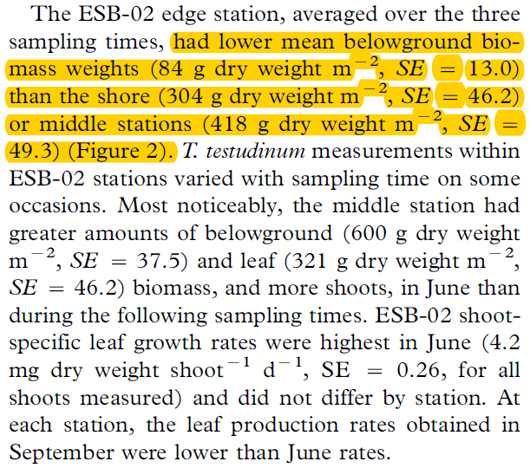

2. The unit for soil C concentration is ‘mmol C/g soil’ for this study, data “0.28” was found from text on page 322.

